

Blood Bank System

Done by:
Abdulaziz Aqlan
Yousef Al-shuhari
Musab Al-slmi
Ahmed Al-yousufi
Mohammed Al-salahi
Supervisor:
Dr. Hamza Jamel

Content:

Table of Contents…………………………………………………….…………………….2-3
System Vision Document .......................................................................................... 4
Problem description: ..............................................................................................4
System Capabilities: ..............................................................................................4
Business benefits: ..................................................................................................4
Stakeholders: ..........................................................................................................5-6
Organization Chart: ..........................................................................................................7
List of Requirement: .....................................................................................................…9
Type of Requirements: ............................................................................................. 9
Interview: ...................................................................................................................... 10
Use case diagram ..................................................................................................... 12
CRUDS (Create, Report, Update, Delete) .................................................................... 17
Use case description ...................................................................................................... 19-20
Event: ............................................................................................................................... 21
Class diagram...................................................................................................................23
Entity and attribute.........................................................................................................24
Use case brief description.............................................................................................25
Activity diagram................................................................................................................29
Challenges.............................................................................................................................34


System vision Document

It’s a system for blood bank to help patients to find the needed blood group easily and quickly.

Problem Description:
Blood is the most valuable gift that anyone can give to another person, but in these days, there are a lot of patients who need blood and do not find the required type. So, we decided to develop a system that helps the blood bank to find donors and provide all blood types.
System Capabilities:
The system should be capable to:
- Show the activity flow of editing, adding and updating of blood.
- Show the activity flow of stock, donor, blood, blood types, patient.
- Manage blood stock of blood bank by recording donor and blood details.
- Alert blood bank employees when the amount of blood is low or when the blood stock has expired.
Business Benefits:
It is anticipated that the deployment of this new system will provide the following business benefits:
- The system helps donors to see the required blood types.
- The system helps patients to get the needed blood type.
- The system facilitates the donation process.
- The system helps blood bank to have all the blood types.
- A user can search for any data available in his/her area.
- Users who are not interested to register he/she also can request for blood in Send Request menu.

Stakeholders

They are the people or individuals who have the full authority to carry out the tasks and have a great opinion on the progress of the work. They are also responsible for the progress of the donating process within the blood bank and work to develop it and run it in the right way and achieve the desired success.
Types of stakeholders:
1- Internal: The internal contributors include the manager and receptionist, and they are the main contributors to the implementation of tasks and finding ideas to solve problems.
2- External: The external contributors include Client, as they are the persons concerned or obligated to carry out the tasks, each according to his work
3- Operational: Operations carried out by the actual implementers in the system.
4- Executive: They are the actual executors to do the tasks required.

Executive
Operational
External
Internal

Organization Chart

A diagram of the organization of jobs among the various departments and their distributions as in the following figure:

List of Requirements

It includes those tasks involved in defining requirements or conditions, considering stakeholder requirements, analyzing, documenting, validating, and managing programs, system requirements, or otherwise is an organized set of information that embodies system requirements and contains a set of use cases that describe all interactions. Between the user and the program. System requirements are mainly divided into two main types functional requirements and non- functional requirements.

Types of requirements:
A) Functional Requirements:
It’s the activities the system must perform:
1- Managing blood:
A- Organizing available blood types
B- Organizing needed blood types
2- Managing donors:
A- Donor’s data
B- Amount of blood given
3- Managing requests:
A- Organizing the blood requests
4- Managing doctors:
A- Their data
B- Organizing a schedule for working hours

B) Non-Functional Requirements:
It’s other system characteristics such as:
1- Reliability:
  - The system will notify blood bank when the amount of blood is low or when the blood stock has expired.
2- Security:
  - Donor’s data will be protected, and it’s not allowed for other users to see your data.
3- Usability:
  - The system will be easy to use, because the user interface will be similar to other interfaces.
4- Performance:
The system will be designed accurately with high performance and it will be permanently updated and there will be no pressure on the server if the system is used by a lot of users.

Interview

A summarization of the interview's place and time, the questions asked and any further interviews to conduct if needed:

Discussion and interview Agenda
Setting:
Objective of interview 1
Understand the procedures that the system will go through
Date, time and location
July 1, 2022, at 10:00AM in
User participants (names and title/positions)
Administrative affairs and several of his staff

Project Team participants
All the team
Q1. What procedures will the system go through?
The system will receive a blood type request from any hospital or laboratory. If the required type is available, the request will be approved and the quantity will be reserved. If it is not available, the request will be rejected.
-----------------------------------------------------------------------------------------------------------
Objective of interview 2
Understand the procedures for searching for donors. If the stock of one of the blood types is less than 3000 ml, the system will send an alert.
Date, time and location
July 3, 2022, at 10:00AM in
User participants (names and title/positions)
Donor selection and screening division
Project Team participants
All the team
Q1. How are donors searched?
Through the posts on the social media, and after obtaining the donors, they are contacted to visit.
Q2. What are the necessary procedures after the donor visit?
The donor is given a form about:
Data of donor such as the type of donation, the donor's name, phone number and type of donor. Examinations such as clinical examination and initial laboratory examination. Health history. Then the doctor evaluates the result through examinations and the answers If it is valid for donation or not valid for donation.

CRUD table

Verified use case | CRUD | Data entity/domain class
Add doctors  Create account  Login in the system | Create | Manager
Look up blood types  Look up clients | Read/Report
Update working hours  Update blood types  Update doctors | Update
Delete Doctors  Delete an account | Delete
Create an account.  Login in the system  Receiving and record the requests. | Create | Receptionist
The form keep in the system | Read/Report
Confirming the request  Update Client account | Update
Delete the request.  Delete the account. | Delete
Create account | Create | Client (donors and patients)
Look up blood types  Look up clients  Look up doctors | Read/Report
Update Client account | Update
Delete Client account | Delete

Use Cases

▪ Use cases: an activity that the system performs, usually in response to a request by an actor. Use cases are made to show how users perform their duties.
User Goal Techniques:
▪ Potential Users:
• Manager
• Receptionist
• Client
Classifying users to functional roles:
- Manager
- Receptionist
- Client.
Classifying users to customers’ evaluation system roles:
- Manager
- Receptionist
- Client
▪Use Cases: What the actors will be able to do?
Manager
Add doctors
Create account
Login in the system
Update account
Look up blood types
Look up clients
Update working hours
Update blood types
Update doctors
Delete Doctors
Delete an account
Receptionist
Create an account
Login in the system
Receiving and record the requests
The form keep in the system
Confirming the order
Delete the order
Delete the account.
Update Client account

Client
Create an account
Look up blood types
Look up clients
Look up doctors
Update Client account
Delete Client account
▪ Users who share the same use cases:
➢ Manger & Receptionist & Client:
Create an account
Delete Client account
Update account

- Managers & Receptionist:
Create an account
Update account
Delete the account.
Login in the system

- Receptionist & Client
Create an account
Update Client account
Delete Client account

Use Cases Diagrams

ADD DOCTOR

Create account

Manager
Log in

Update accounts

Look up blood types
Update working hours
Delete an account

Delete doctor

Update doctor

Update blood types

Look up client types

Create an account

Receiving and record the requests
Receptionist

The form keep in the system

Confirming the order
Delete the account
Update client account

Delete the order

Create an account

Look up blood types
Client

Look up clients

Look up doctors

Delete client account
Update client account

Use Cases Description

Use case | Description
Add doctor | The manager creates a new doctor account, and the system will create a record of a new account.
Look up blood types | The manager enters blood type name, and the system displays it.
Update working hours | The manager adjusts working hours, and the system notifies employees and records the transaction.
Delete doctor | The manager deletes doctor account, and the system drops its record.
Confirm request | The receptionist confirms order and the system sends confirming message to the hospital.
Delete request | The receptionist rejects order and the system sends rejecting message to the hospital.
Update account | The receptionist edits an existing client account, and the system creates a transaction record.
Add account | The client creates a new account, and the system will create a record of a new account.
Look up doctors | The client enters doctor’s name, and the system display it.

Events

Is something that occurs at specific time and place, can be described, and should be remembered by the system.
External Events
    - Client wants to create account
    - Client wants to view available blood types
    - Client wants to update account
    - Client wants to delete account

Temporal Events
    - Produce donation report (every month)
    - Produce blood groups stock report (every week)

State Events
    - Send an alert when the stock of one of the blood types is less than 3000 ml.
    - Send a notification for employees when the manager updates working hours.

Class Diagram
A class diagram in the Unified Modeling Language is a type of static structure diagram that describes the structure of a system by showing the system's classes, their attributes, operations (or methods), and the relationships among objects.
Manager
Manager_ Id
Manager_ Name
Manager_ Phone

g

Reception
Reception_ Id
Reception_ Name
Reception_ Phone

Request
Request_ Id
Request_ Date
Request Description

Clients
Client_ Id
Client_ Name
Client_ Phone

Doctors
Doctor_ Id
Doctor_ Name
Doctor_ Phone

Result
Result_ Name
Result blood_ Type

Stock Control
Stock_ User Name
Stock_ Password
Stock_ Blood Type
Stock_ Quantity

Entity and Attribute

Entity: a single unique object in the real world that is being mastered.
Attribute: a characteristic or trait of an entity type that describes the entity.

Manger | the one who has all the promotions in the system
ID | unique id for the manger
Name | name of the manger
Phone | the number of the manger

Reception | Witch data needs to be held the reception
ID | unique id for the reception
Name | name of the reception
Phone | the number of the reception

Request | Arises when client requests blood type
ID | unique id for the request
Date | The time of the request
Description | the number of the request

Client | The person who need to donates in the bank
ID | unique id for the client
Name | name of the client
Phone | the number of the client

Doctor | The person who examines the donor
ID | unique id for the doctor
Name | name of the doctor
Phone | the number of the doctor

Result | Arises after examines the donor
Name | If it is valid for donation or not valid for donation
Blood Type | Blood type of donor

Stock control | The
User name | Name for the Stock control
Password | Password for the Stock control
Blood Type | What are the types of blood in the stock control
Quantity | How much of blood type in the stock control

Use Case Brief Description

It is a document that explains the functionality of the system use cases.
Add doctors:
Use case name | Add doctors
Scenario | Create doctor account.
Triggering event | Manager add doctor account.
Brief description | The Manager enter doctor in the system .
Actor | Manager.
Related use case | --
Stakeholders | Manager and doctor
Precondition | More experience
Post condition | Actors
Flow of activities | Actor | System
 | 1) the manager open the add division  3)the manager choose the add division option  5)the manager choose doctor account  7)the manager adds the division and submit them | 2)the system display the add division option  4)the system show list of division categories add  6)the system sets out doctors accounts that a manager is responsible  8)the system saves the division

Update client account
Use case name | Update client account
Scenario | Update client.
Triggering event | Client want to update his account.
Brief description | The reception enter new value for existing data.
Actor | Reception.
Related use case | Search of account client.
Stakeholders | Client- Reception.
Precondition | Client must exit.
Post condition | Client must print and send.
Flow of activities | Actor | System
 | 1) open client page.  3the reception choose update client.  5)the reception update client. | 2)the system display client.  4)the system show the template of update client.  6)the system saves the change of client.
Exception condition | Client is missing.
Delete request:

Use case name | Delete request
Scenario | Delete a request for client.
Triggering event | Reception delete request.
Brief description | Delete in repetition.
Actor | Reception.
Related use case | none.
Stakeholders | Reception – client.
Precondition | client must exit.
Post condition | ----.
Flow of activities | Actor | Head of department
 | 1) the reception opens the delete client page  3)the reception choose the delete client option  5)the reception choose the client that want delete. | 2)the system display the delete client option.  4)the system show list of client.  6)the system delete the client that a reception select.
Exception condition | A client is take it or fail.

Create account:
Use case name | Create account
Scenario | Create account.
Triggering event | Any on must create account to use the system
Brief description | The manager enter new account for existing data.
Actor | Manager .
Related use case | Show stock control and other divisions.
Stakeholders | Manager .
Precondition | Account must exit.
Post condition | -----
Flow of activities | Actor | System
 | 1) the manager choose add account.  3the manager enter the name that want to have account. | 2)the system display the add account option .  4)the system add the account.
Exception condition | Account is missing

Activity Diagram

Activity diagram is another important behavioral diagram in UML diagram to describe dynamic aspects of the system. Activity diagram is essentially an advanced version of flow chart that modeling the flow from one activity to another activity.

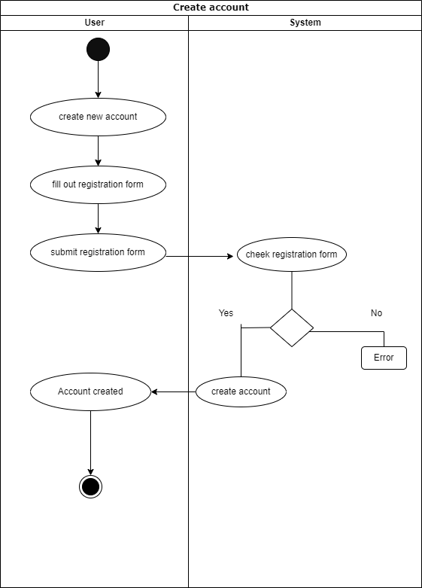

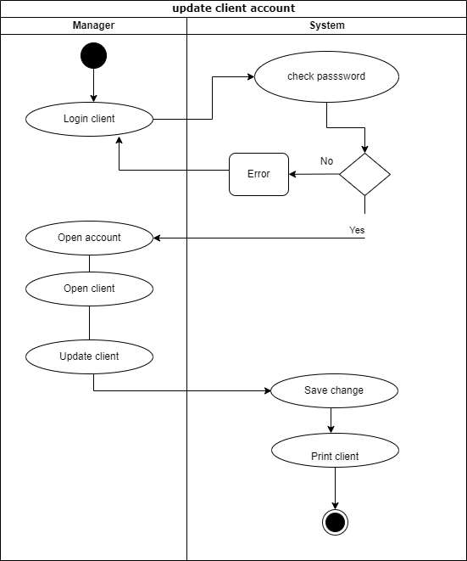

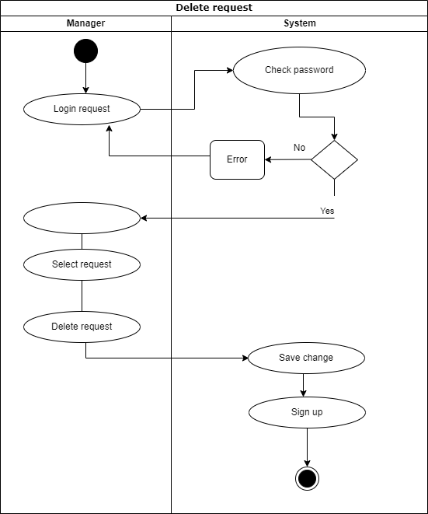

Challenges

The idea of ​​our system is to create a blood bank system that helps hospitals and laboratories by providing all the required blood types which is our system. The project was a huge challenge for the two of us for the time and pressure of studying. It took us a lot of time during that time. We encountered some problems. At the beginning of the analysis, the biggest challenge was collecting the required and correct data. After we decided what our system could do and what the functional requirements were, we started research to collect data from the internet and did some interviews with hospital owners and laboratories. Next we determined how to use the system and who will use it. Then we make a use case diagram and table with a description of each use case, after which we count the events in our system. We made the class and entity diagram with its own property, and at the end we made the activity diagram. We complete our system. In the end, analyzing an entire system from scratch is a challenge. And now we have completed this stage. We will face the design phase with all effort and perseverance as we did here

